Poetry Readings
in the voice of
BUD RUE

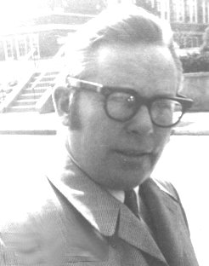

1934-1993

From an audio cassette made by him for a 1974 class at Princeton Middle School of selected
favorites from The Golden Treasury of Poetry by L. Untermeyer, Golden Press, N.Y., 1959.

Poetry Readings – Bud Rue
Poetry Readings – Bud Rue

- Invictus
- The Fish
- If No One Ever Marries Me
- A Dangerous Toy
- If
- Every Time I Climb A Tree
- I Meant To Do My Work
- The Highwayman
- I Remember, I Remember
- Miracles
- There Was A Child
- You Have No Enemies
William Ernest Henley
Elizabeth Bishop
Lawrence Alma-Tadema
Hilaire Belloc
Rudyard Kipling
David McCord
Richard LeGallienne
Alfred Noyes
Thomas Hood
Walt Whitman
Walt Whitman
Charles Mackay

Produced 12-20-2002 by Tom Rue, POB 706, Monticello, NY 12701, for nonprofit and educational use only.

Bud Rue Memorial Walk for Social Justice - http://budruewal.tripod.com

